Extra problems:
Ques:
A capacitor of capacitance 102/π µF is connected across a 220 V, 50 Hz A.C. mains. Calculate the capacitive reactance, RMS value of current and write down the equations of voltage and current.

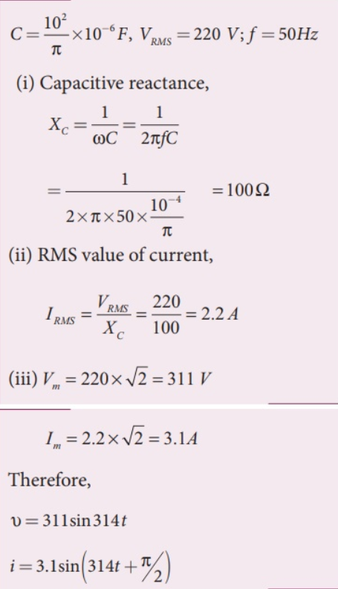
Solution:

